Fred J. and Nora H. Sonderup
Trust Fund
St. Paul, Nebraska

Jeffrey J Varney & Bobbi J Placke Valerie Killinger
Co-Trust Officers-Citizens Bank and Trust Chairman
721 7thSt. Board of Trustees
P.O. Box 385
St. Paul, NE 68873

Dear Fred J. and Nora H. Sonderup Trust Applicant,

Included with this letter is the Sonderup Trust Grant application as well as the Sonderup Trust Calendar of Events concerning your application. To guide you through the application, the Board of Trustees would like to point out a couple items of importance to help you complete the application.

It is very important that all of the questions on the application be answered completely. The more details that are provided, the easier it is for the Board of Trustees to understand your project. If the space provided is not adequate for your details, feel free to attach extra page(s) with the application. If you do not understand a question on the application, please call the Trust Officer for verification.

All applications are required to be typed. Some of the past applications have not photocopied well or the handwriting was not legible.

Grant funds are to be used for the benefit of Howard County residents. Funds are limited; thus, not all qualified applications will be selected. The board will judge the merits of each application, and those projects will be funded as the board deems most beneficial to Howard County.

Other things to consider – in the past, there have been some worthwhile projects that did not receive funding due to the board not being able to fully understand the details of the project. Complete your application assuming the board knows nothing about your project. Past boards have partially funded projects which have also raised funds outside of the grant being requested.

Thank you.

Sincerely,

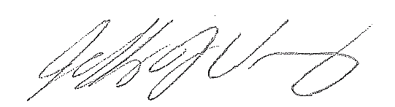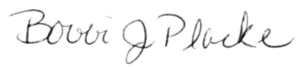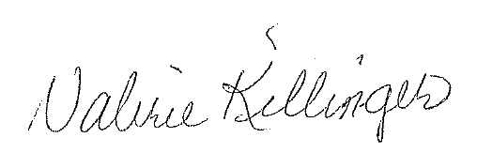
Jeffrey J Varney Bobbi J Placke Valerie Killinger
Co-Trust Officer Co-Trust Officer Chairman of the Board of Trustees

SONDERUP TRUST CALENDAR OF EVENTS

DATE EVENT

First week of September The Trustee issues a press release to
the Phonograph Herald announcing
the availability of applications for
grants and submission deadline.

November 1st Deadline for receipt of reports from
grant recipients as to the status of
grant funds received in prior years.

November 15th Deadline for submission of
applications for grants to the Trustee.

By November 20th Copies of applications for grants are
forwarded to the Board of Trustees.

First Tuesday of December Annual Meeting of the Board of
Trustees

By December 20th Board of Trustees issues a press
release announcing the recipient
of grants awarded at the annual
meeting. Minutes of the meeting
are delivered to the Trustee for
preparation of grant checks
and forwarding letters.

APPLICATION FOR GRANT
FRED J. AND NORA H. SONDERUP TRUST FUND
Application # ________
Applicant:
Address:
(Street, City, State, ZIP)
Contact Person:
(Name, Title, Phone #)

Instructions: This application for a grant from the Fred J. and Nora H. Sonderup Trust Fund must be submitted by organizations or individuals requesting a grant from the Fund as established in the Last Will and Testament of Nora H. Sonderup. Grants will be made to (1) charitable organizations which distribute or expend money for charitable purposes in Howard County, Nebraska and/or to or for the use of governmental agencies and instrumentality’s for exclusively public purposes in Howard County, Nebraska. “Charitable organizations” shall mean those corporations, trusts, community chests, funds, or foundations, which are organized and operated exclusively for religious, charitable scientific, literary, or educational purposes. (2) For education needs of the youth of Howard County especially for those individuals interested in pursuing a course of medical training. Grants will not be made to political campaigns, candidates, to an enterprise operated for profit, or for the benefit of any private shareholder or individual.

The application must be filled out in detail so that the Trustees can evaluate the request’s merit based on the information presented in the application. The application must be typed. A personal appearance before the Board of Trustees by the applicant is not anticipated. Clarification of the application may be requested in special circumstances. Failure to provide all requested information may result in rejection of the application. Do not leave any item blank. If an item does not apply to your application, enter NA (not applicable). If you are requesting funds for more than one item, list each item separately along with the cost of the item and also the grant request.

General classification of applicant (check one):

☐Religious ☐Cultural ☐Health
☐Educational ☐Social Welfare ☐Government
☐Character building ☐Recreation ☐Other

Is applicant IRS tax exempt? ☐ Yes ☐ No

(If applicable)
Federal ID Number:

Describe the principal purpose of the organization:

Is the organization incorporated? ☐ Yes ☐ No
Date Incorporated:

List the names and titles of all Officers and/or Directors:

Approximate number of members in your organization:

What group of persons will benefit from your project and/or the grant funds?

What are the major funding sources for your organization?

Project or purpose for which this grant is requested: Please be specific. (Attach plans, brochures,
prices, drawings, etc. if appropriate)

Planned start date for your project?
Planned finish date?

What is the total cost of this project/program? $
Funds available, budgeted, or pledged for this project/program? $
Amount you are requesting as a grant from Sonderup Trust? $
Balance required to finish financing the project/program? $

If additional funds are required, how do you plan to raise them?

Provide a brief statement justifying your request for a grant?

Certification

I certify the above application is submitted with appropriate approval of the members of the requesting organization or their representatives and that I/we will utilize any funds that may be granted solely for the purpose(s) as described in this application. I/we will submit reports of expenditure of funds as may be requested by the Sonderup Board of Trustees. I/we will preserve any funds granted and return them to the Sonderup Trust if the project/program for which funds are granted is cancelled, materially reduced in size or scope, or a start is delayed for 12 months from the start date listed on the application.

(Signature) (Title) (Date)

Endorsement by Supervisory or Parent Organization

If this application is submitted by a school program, a committee or similar sub-division of a larger organization, the following endorsement must be completed.

From:
(Superintendent of schools, president, chairman, etc.)

I have reviewed the above application and it is forwarded recommending approval. The requested project/program will receive appropriate support and ongoing funding, if required, from this organization.

(Signature) (Date)

Mail or deliver completed application to: Citizens Bank and Trust Co.
Attn: Trust Officer
721 7th St.
PO Box 385
St. Paul, NE 68873
Applications can also be emailed to: bplacke@bankwithcitizens.com.

Disclaimer: Citizens Bank & Trust Co. is not involved in the decision-making process regarding the awarding of Fred J. and Nora H. Sonderup Trust grant funds.

